Source ID - 77910899

Source Title - Gongcheng Lixue/Engineering Mechanics

Agreement URL - http://engineeringmechanics.cn/

NOTE – English and Chinese TOC should be captured.

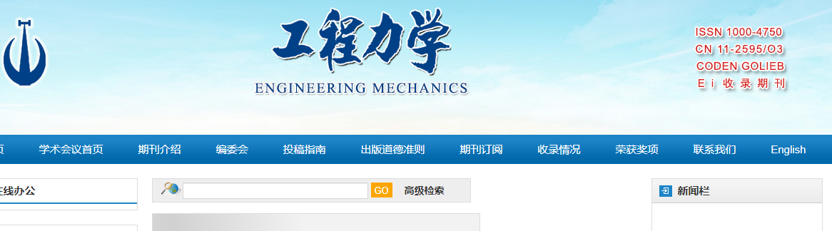

Click to view English translation

Click current issue

Click article title to capture meta data

Volume issue and year

Page range

DOI number

Article title

Click to download XML

Click to download PDF

Volume issue month and year